INFOSYS SPRING BOARD INTERNSHIP 7.0
PROJECT DOCUMENTATION REPORT

Organizational Knowledge Gap
Intelligence Platform
DOMAIN: JAVA FULL STACK TECHNOLOGY
Project Duration: 8 Weeks
Submitted by:
Roshan Kullu
Email:itsmeroshan198@gmail.com
TEAM-01
BATCH-01

ABSTRACT
Modern organizations struggle to see, in real time, where their workforce's skills fall short of what each role actually demands. Skill data is scattered across spreadsheets, appraisal forms and training logs, so gaps are usually discovered only after a project has already been delayed or a client escalation has already happened. The Organizational Knowledge Gap Intelligence Platform (OKGIP) was built to close that visibility gap: it gives every employee, manager, HR specialist and L&D administrator a single system of record for skills, competency requirements, assessments, training and mentorship.
The platform is implemented as a full-stack web application with a React 18 single-page front end and a Spring Boot 3 / Java 17 REST back end, secured end-to-end with stateless JWT authentication and role-based access control across six organizational roles (Employee, Manager, HR, Department Head, L&D Admin and Admin). At its core sits a Knowledge Gap Analysis Engine that compares each employee's recorded proficiency against the competency framework defined for their role and department, producing a severity-scored gap list, a readiness percentage and an aggregated department heatmap. A companion Recommendation Engine converts unresolved gaps into a ranked, sequenced learning path drawn from an internal and external training catalogue. Around this core, the platform layers a multiple-choice assessment engine with automatic proficiency derivation, an enrollment and progress-tracking workflow, a mentorship-matching module built on skill complementarity, a knowledge-article repository, an in-app notification centre and role-differentiated analytics dashboards for employees, managers and the organization as a whole.
This report documents the system as actually implemented across Milestones 1–3 of the project: twelve functional modules, a normalized relational schema of thirteen core entities, and a documented set of 45+ REST endpoints. The report presents the system architecture, entity-relationship model, control-flow and data-flow diagrams, a module-by-module implementation walkthrough with representative code, the testing and validation approach, and the production-hardening challenges encountered along the way. Where the original project brief specified enterprise-scale infrastructure that sits outside the delivered scope — an API gateway, a distributed cache, a search cluster, an event broker and third-party LLM/SMS/push integrations — this report documents those honestly as a scoped roadmap in Chapter 7 rather than as delivered functionality, so that the document remains an accurate technical record of the system as it stands today.

Keywords
Knowledge Gap Analysis, Skill Inventory, Competency Framework, Spring Boot, React, JWT Authentication, Role-Based Access Control, Training Recommendation Engine, Learning Management, Mentorship Matching, Workforce Analytics.
TABLE OF CONTENTS
Title Page 1
Abstract 2
2. Project Overview & Objectives 6
2.1 Introduction 6
2.2 Core Objectives 6
2.3 Key Outcomes — Milestones Achieved 7
3. System Requirements & Tech Stack 9
3.1 Functional Requirements Summary 9
3.2 Non-Functional Requirements 9
3.3 Technology Stack 10
3.3.1 Frontend Layer 10
3.3.2 Backend Layer 11
3.3.3 Data Layer 11
3.4 Extended / Roadmap Technologies (Not Yet Implemented) 11
4. Architecture & Technical Design Diagrams 13
4.1 System Architecture Diagram 13
4.2 Entity-Relationship (ER) Diagram 14
4.3 Control Flow / Component Interaction Diagram 15
4.4 Data Flow Diagram (DFD — Level 1) 16
5. Module-Wise Detailed Implementation 18
5.1 Module 1 — User Authentication & Role-Based Access Control 18
5.2 Module 2 — Employee Profile & Skill Inventory Module 19
5.3 Module 3 — Competency Framework & Role Benchmarking Module 21
5.4 Module 4 — Knowledge Gap Analysis Module 22
5.5 Module 5 — Training Recommendation Module 24
5.6 Module 6 — Knowledge-Sharing & Mentorship Module 25
5.7 Module 7 — Learning Progress Tracking Module 27
5.8 Module 8 — Assessment & Survey Module 29
5.9 Module 9 — Notification Module 31
5.10 Module 10 — Analytics Dashboard Module 32
5.11 Module 11 — Reports & Export Module 33
5.12 Module 12 — Final Integration, Testing & Deployment 34
6. Testing, Validation & Code Quality 35
6.1 Unit & Integration Testing 35
6.2 API Validation 36
6.3 Code Quality Practices Observed 36
7. Challenges Overcome & Future Enhancements 38
7.1 Design Challenges Overcome 38
7.2 Known Limitations of the Current Build 39
7.3 Production-Level Blockers Anticipated for the Roadmap Items 40
7.4 Future Enhancements & Scalability Roadmap 41

2. PROJECT OVERVIEW & OBJECTIVES

2.1 Introduction
Employee skills change faster than most organizations can track them. A developer who was 'proficient' in a framework eighteen months ago may now be behind the version the team has since adopted; a newly promoted manager may never have had their leadership competencies formally assessed at all. Left unmanaged, these silent gaps between what a role requires and what an employee actually knows translate directly into missed deadlines, quality issues and reactive, poorly targeted training spend.
The Organizational Knowledge Gap Intelligence Platform addresses this by giving every layer of the organization — the individual employee, their manager, HR, and L&D administrators — a shared, continuously updated view of skill proficiency against role expectations. Rather than a static annual appraisal, the platform treats skill data as a living record: self-assessments, peer input, manager evaluation and quiz-based assessments all feed the same proficiency inventory, and every update automatically recalculates the employee's gap profile, their training recommendations and their contribution to departmental analytics.

2.2 Core Objectives
The project set out to design and build a cohesive full-stack platform rather than a collection of disconnected screens. The core objectives were:
- Build a React.js single-page front end that gives each role (Employee, Manager, HR, Department Head, L&D Admin, Admin) a purpose-built dashboard rather than one generic view.
- Build a Spring Boot back end exposing a secured, versionable REST API that a mobile client or a third-party integration could consume identically to the web front end.
- Model a competency framework that is data-driven (stored per job role and department) rather than hard-coded, so HR can redefine 'what good looks like' for a role without a code change.
- Continuously assess employee profiles against that framework and surface the result as a severity-scored, prioritized gap list — not just a raw score.
- Turn every unresolved gap into an actionable, ranked learning intervention, and track that intervention through to completion and skill uplift.
- Support peer-to-peer knowledge transfer (mentorship, knowledge-sharing sessions, articles) as a lower-cost complement to formal training.
- Give managers, HR and leadership organization-level visibility (heatmaps, readiness trends) without exposing every individual's raw data indiscriminately.

2.3 Key Outcomes — Milestones Achieved
The project was executed over an 8-week timeline and organized into five delivered milestones, each adding a coherent slice of functionality on top of the previous one rather than working front end and back end in isolation:
Table 2.1 — Delivery Milestones and Scope
Milestone | Scope Delivered
M1 — Foundation | Project scaffolding (Spring Boot + React + Vite), PostgreSQL/H2 data source configuration, and the initial domain model (User, Skill, EmployeeSkill).
M2 — Identity & Framework | JWT authentication, registration, role-based access control across 6 roles; employee skill inventory (5 proficiency levels); role/department competency framework with criticality flags.
M3 — Gap & Recommendation Engines | Individual gap detection with severity scoring, team/department gap heatmap; relevance-scored training recommendation engine and generated learning paths.
M4 — Sharing, Progress & Assessment | Mentorship matching on skill complementarity, knowledge-sharing sessions and articles; learning enrollment / progress tracking with skill uplift on completion; multiple-choice assessment engine (45 questions across 6 skill areas) with server-side grading.
M5 — Analytics, Notifications & Hardening | Employee / manager / organization analytics dashboards, in-app notification centre, end-to-end integration pass, and preparation of this documentation deliverable.

Across these milestones, twelve functional modules (detailed in Chapter 5), thirteen core JPA entities (Chapter 4.2) and over forty-five REST endpoints (summarized per module in Chapter 5, and in full in the project README) were implemented and demo-seeded with realistic sample data covering four representative user accounts spanning all primary roles.

3. SYSTEM REQUIREMENTS & TECH STACK

3.1 Functional Requirements Summary
- Secure registration and login with role assignment and stateless session handling.
- Employee-maintained skill inventory rated on a five-level proficiency scale.
- HR/L&D-maintained competency framework mapping required proficiency per skill to each job role and department, with a criticality flag.
- Automated, on-demand gap analysis for any employee, and aggregated heatmaps at team/department level.
- Relevance-ranked training recommendations and a generated, sequenced learning path per employee.
- Enrollment, progress tracking (0–100%) and completion workflow for training programs, with automatic skill-level uplift on completion.
- A quiz-based assessment engine with explanations and server-side derivation of proficiency level from score.
- Mentor–mentee matching based on complementary skill gaps/strengths, plus session scheduling and a knowledge-article library.
- An in-app notification centre reporting gap alerts, recommendations, milestones and mentorship events.
- Role-differentiated analytics dashboards for Employee, Manager and Organization-wide audiences.

3.2 Non-Functional Requirements
- Security: password hashing (BCrypt), stateless JWT bearer authentication, per-endpoint role authorization, and a configured CORS policy.
- Portability: identical codebase runs against an in-memory H2 database for local development/demo and PostgreSQL for a persistent deployment, switched purely by Spring profile.
- Usability: role-specific navigation and dashboards so each user only sees screens relevant to their responsibilities.
- Maintainability: a layered back-end architecture (controller → service → repository → entity) and a componentized React front end (pages, shared UI components, a single Axios API client, a shared Auth context).
- Auditability: every skill rating records its source (self, peer, manager or assessment) and every training enrollment records its timestamps.

3.3 Technology Stack
The table below documents the technology stack exactly as implemented in the delivered codebase. A small number of items called for in the original project brief — noted separately in §3.4 — describe an extended, enterprise-scale target architecture that was scoped out of the current milestones and is carried forward as a roadmap item in Chapter 7 rather than misrepresented here as delivered.

3.3.1 Frontend Layer
Technology | Role in the Application
JavaScript (ES2020+) | Primary application language for the client.
React 18 | Component-based single-page application framework.
Vite | Development server and production build tool.
React Router | Client-side route management across role-specific pages.
Axios | Centralized HTTP client (src/api/client.js) attaching the JWT bearer token to every request.
Context API | AuthContext — shared, app-wide authentication/session state without prop drilling.
Tailwind CSS | Utility-first styling for all pages and shared UI components.
Recharts | Charting library powering the Analytics dashboards and gap heatmap visualisation.

3.3.2 Backend Layer
Technology | Role in the Application
Java 17 | Primary back-end language (records, enhanced switch used where applicable).
Spring Boot 3.3 | Application framework — auto-configuration, embedded Tomcat, dependency injection.
Spring Security | Authentication/authorization pipeline; stateless session policy; custom JwtAuthFilter.
Spring Data JPA | Repository abstraction over the entity model (15 repository interfaces).
Hibernate | JPA provider — ORM mapping, lazy loading, schema generation (ddl-auto: update).
Maven | Build tool and dependency management (pom.xml).
jjwt (io.jsonwebtoken) | JWT issuing and verification library used by JwtService.
Lombok | Boilerplate reduction (getters/setters/builders) on entity and DTO classes.

3.3.3 Data Layer
Technology | Role in the Application
H2 Database | In-memory relational database for local development and demonstration; auto-seeded on startup.
PostgreSQL | Production-grade relational database, activated via the postgres Spring profile without any code change.

3.4 Extended / Roadmap Technologies (Not Yet Implemented)
The original project brief additionally specified an enterprise integration surface — Spring Cloud Gateway, Redis, Elasticsearch, Apache Kafka / RabbitMQ, the OpenAI API, Twilio SMS, Firebase Cloud Messaging and JavaMailSender — sized for a distributed, multi-service deployment. None of these appear in the delivered codebase reviewed for this report: the current system is a well-layered Spring Boot monolith with synchronous REST calls and an in-app notification model. Rather than describe simulated integrations as built, this report lists them here as scoped future work and expands on an integration plan for each in Chapter 7.4.
Planned Technology | Intended Purpose
Spring Cloud Gateway | Single edge entry point, centralized rate limiting and routing if the monolith is split into services.
Redis | Caching layer for gap-analysis and dashboard read paths under higher concurrent load.
Elasticsearch | Full-text and fuzzy search across skills, mentors and knowledge articles at larger data volumes.
Apache Kafka / RabbitMQ | Asynchronous event bus decoupling gap recalculation and notification dispatch from the request path.
OpenAI API / LLM | Adaptive, language-model-assisted re-ranking of training recommendations, referenced as a design hook in RecommendationService.
Twilio SMS / Firebase Cloud Messaging | Out-of-band SMS/push channels to complement the current in-app notification centre.
JavaMailSender | Transactional email delivery (welcome emails, deadline reminders).

4. ARCHITECTURE & TECHNICAL DESIGN DIAGRAMS
This chapter presents the platform's structural design: how requests move through its layers, how the relational schema is organized, and how data flows between the client, the business services and persistent storage. Every diagram below reflects the system as implemented; where the diagram also marks a planned extension (greyed / dashed elements), that distinction is called out explicitly rather than left ambiguous.

4.1 System Architecture Diagram
The platform follows a classic layered (monolithic) architecture rather than a distributed microservices topology. This was a deliberate scope decision for the project timeline: a well-separated monolith is simpler to reason about, test and deploy for a system of this size, while still keeping each layer thin enough to extract into an independent service later if load or team structure demands it. The Client Layer is a React single-page application that never talks to the database directly — every interaction goes through the API Layer, where Spring Security's JwtAuthFilter validates the bearer token and populates the security context before Spring's role-based authorization rules are evaluated. Nine Service-layer components encapsulate all business logic (auth, profile/skills, gap analysis, recommendations, learning, assessment, mentorship/knowledge, analytics, notification), each backed by one or more Spring Data JPA repositories and, ultimately, the relational datastore.
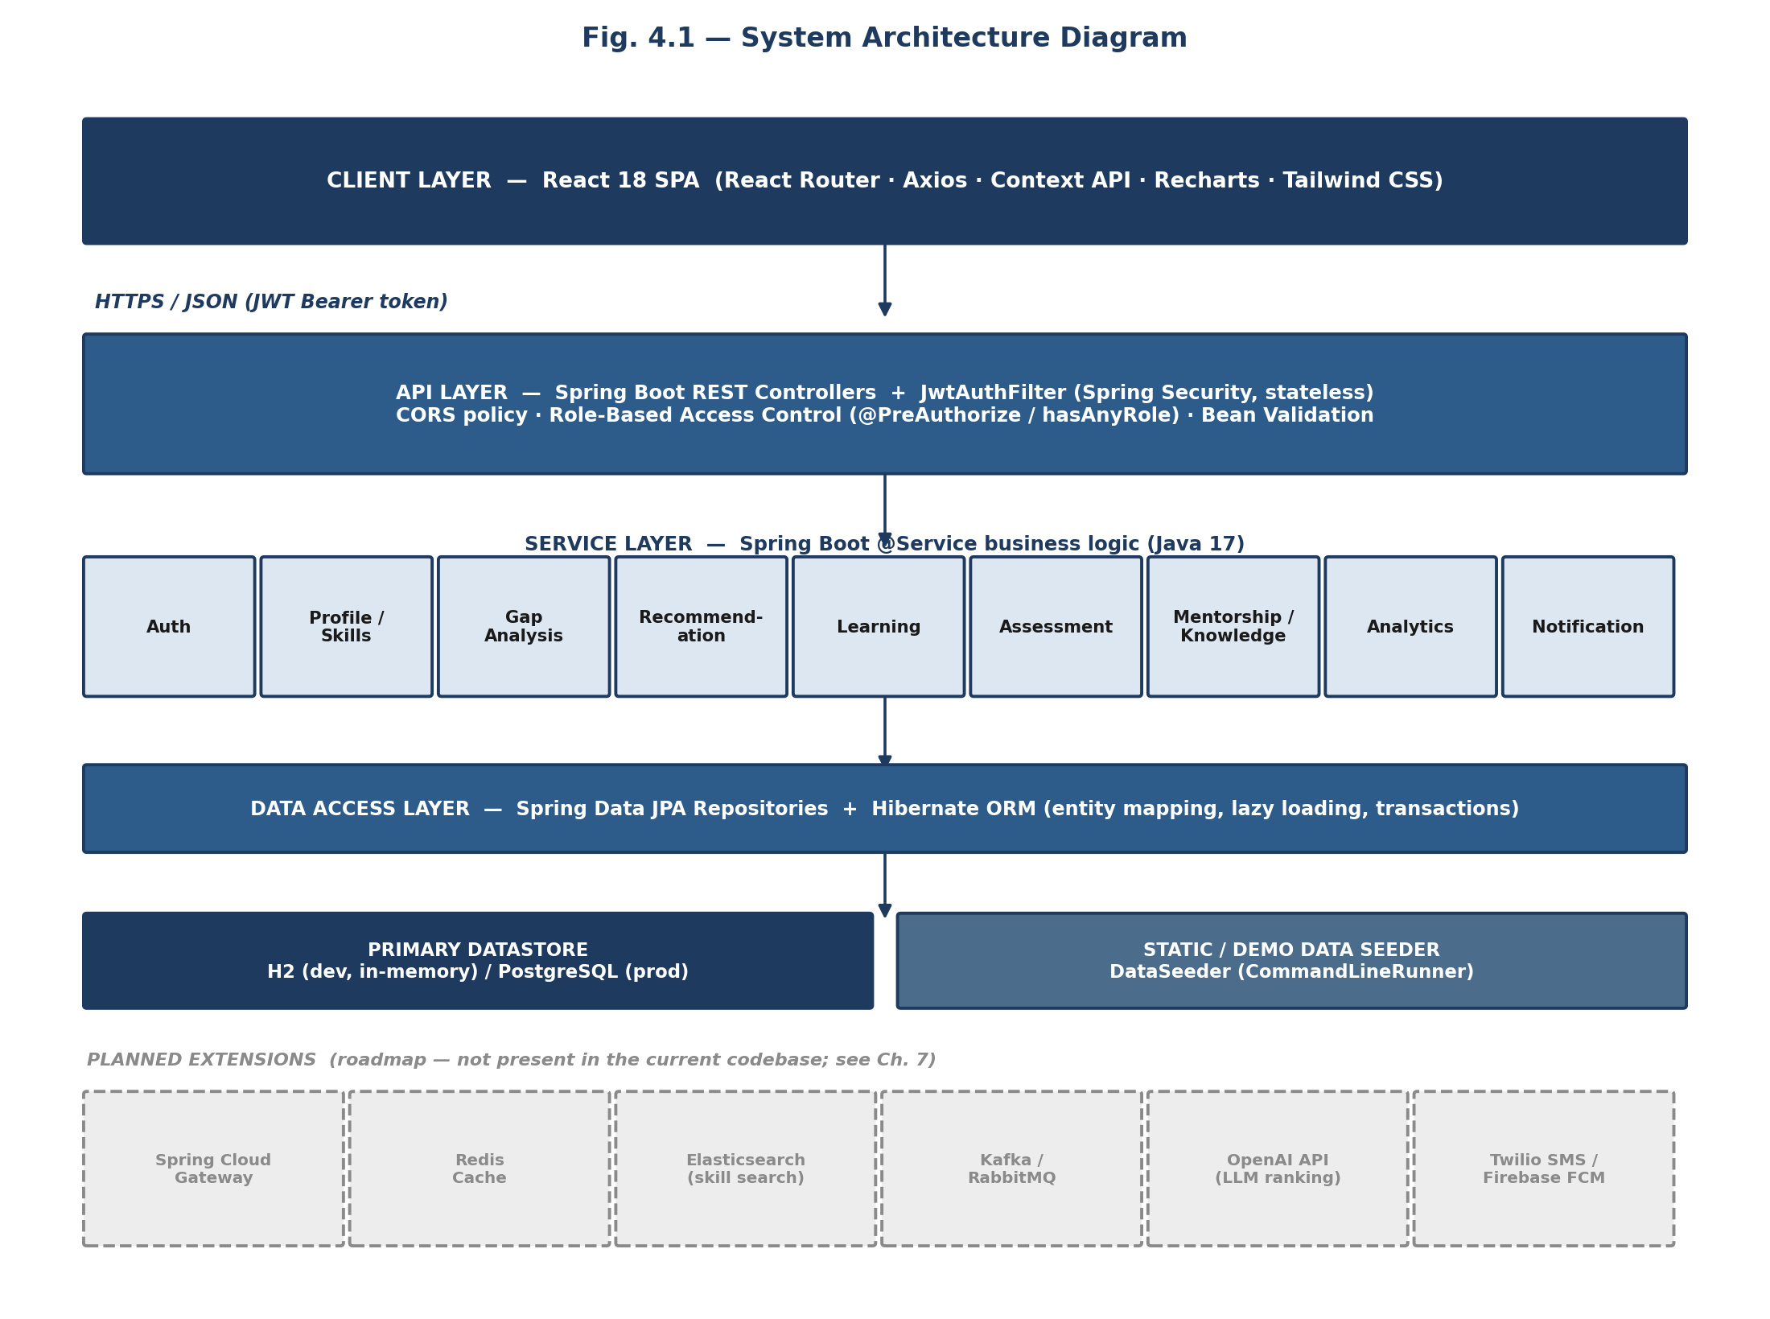
Figure 4.1 — System Architecture Diagram
The bottom row of the diagram marks the enterprise extensions called for in the original project brief (API gateway, cache, search, message broker, LLM ranking, SMS/push) as a dashed, greyed-out roadmap layer. These are discussed as future scalability work in Chapter 7.4 and are not part of the delivered system.

4.2 Entity-Relationship (ER) Diagram
The relational schema is anchored on two hub entities — USERS and SKILL — with every other table expressing either 'what a user knows/needs' (EMPLOYEE_SKILL, ROLE_COMPETENCY) or 'what a user did about it' (ENROLLMENT, ASSESSMENT_ATTEMPT, MENTORSHIP_MATCH, SHARING_SESSION, KNOWLEDGE_ARTICLE, NOTIFICATION). Skills tables (SKILL, EMPLOYEE_SKILL) capture the raw proficiency inventory; the gap-analysis tables (ROLE_COMPETENCY) express organizational requirements against which that inventory is compared at request time — gaps themselves are computed on demand by GapAnalysisService rather than persisted, so there is deliberately no GAP table: this keeps the gap result always consistent with the latest skill and competency data. Training & enrollment tables (TRAINING_PROGRAM, ENROLLMENT) and user/profile tables (USERS and its dependents) complete the schema.
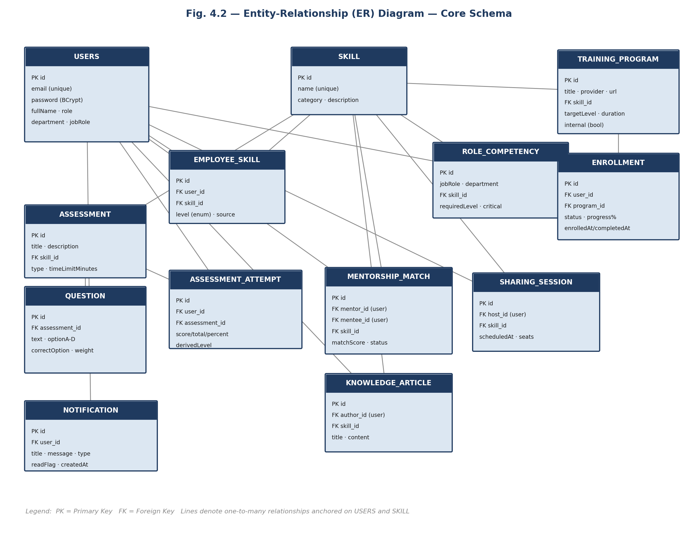
Figure 4.2 — Entity-Relationship Diagram — Core Schema
All thirteen entities use a surrogate IDENTITY primary key. Every foreign key is enforced at the JPA mapping level via @ManyToOne associations; Hibernate generates the corresponding physical foreign-key constraints from ddl-auto: update in development, and the same entity model targets PostgreSQL unchanged in the postgres profile.

4.3 Control Flow / Component Interaction Diagram
The diagram below traces a single representative operation end-to-end — an employee submitting a skill assessment — through every architectural layer, since this flow touches the largest number of subsystems in one request: authentication, grading, skill-inventory update, gap recalculation, recommendation re-scoring and notification.
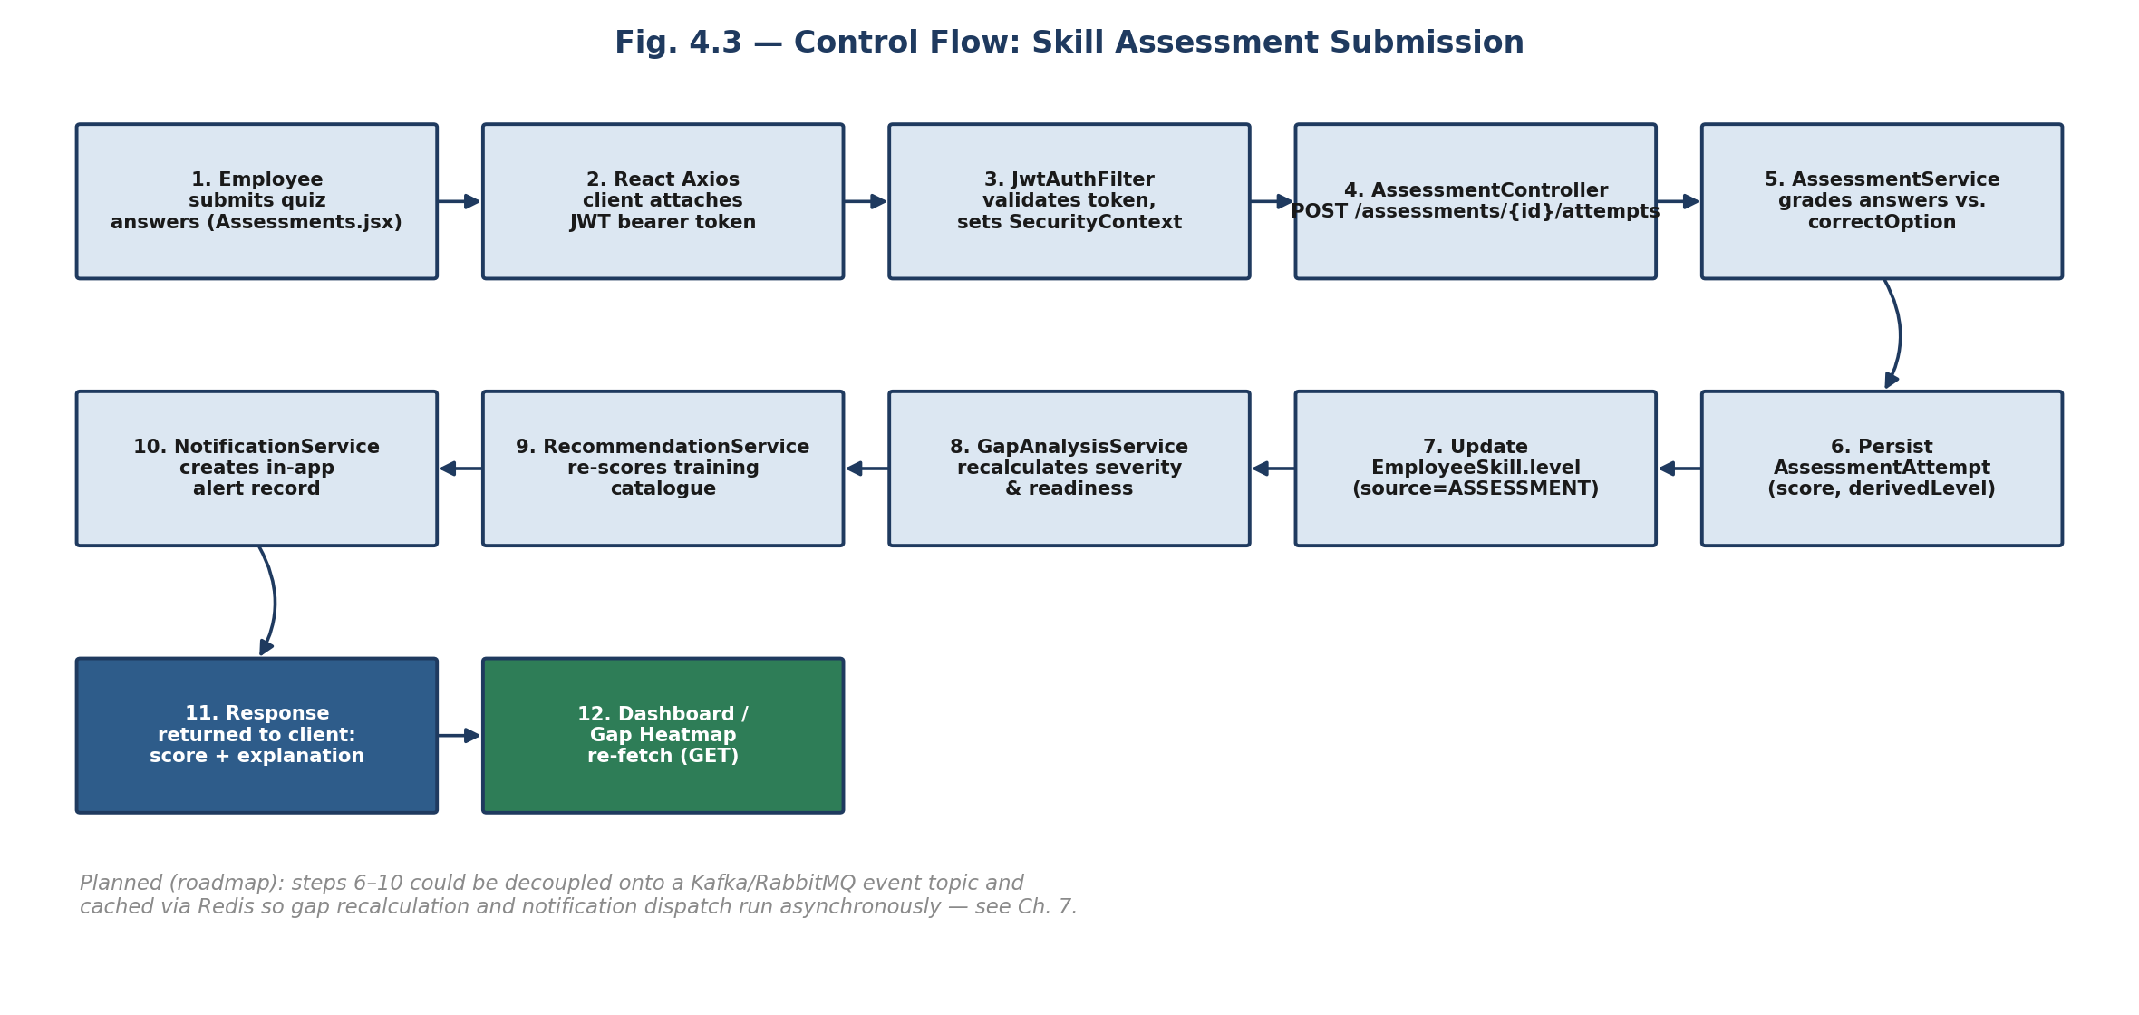
Figure 4.3 — Control Flow — Skill Assessment Submission
Steps 6–10 execute synchronously within the same HTTP request/response cycle today. The diagram's closing note flags these as the natural seam for the Kafka/RabbitMQ + Redis roadmap item in Chapter 7.4, since decoupling them onto an event topic would let the request return as soon as the attempt is graded, with gap recalculation and notification dispatch happening asynchronously.

4.4 Data Flow Diagram (DFD — Level 1)
The Level-1 DFD abstracts away controller/service mechanics and shows, at the process level, how data moves between the platform's three external entities (Employee, Manager/HR/L&D Admin, and the demo data seeder acting as a system-triggered source), the nine core processes and the seven persistent data stores that back them.
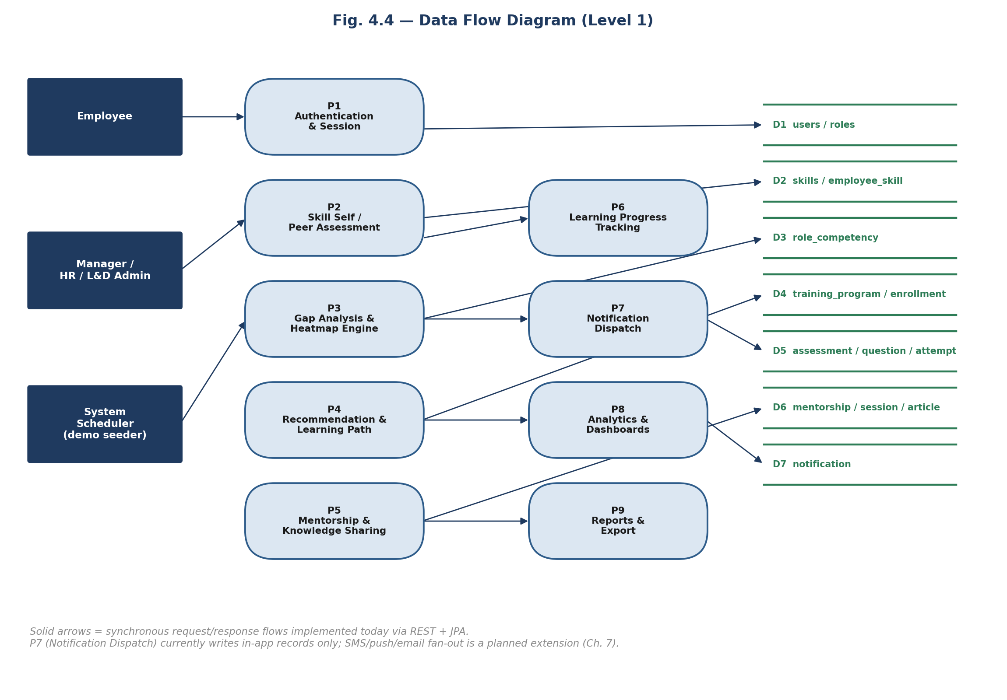
Figure 4.4 — Data Flow Diagram (Level 1)
Every flow drawn as a solid arrow is implemented today as a synchronous REST call resolved against the relational store. The notification process (P7) currently writes rows to the NOTIFICATION table for in-app display only; fan-out to SMS, push and email — implied by 'asynchronous flow of real-time messaging' in the original brief — is scoped as future work rather than claimed here as delivered, consistent with §3.4.

5. MODULE-WISE DETAILED IMPLEMENTATION
This chapter walks through all twelve functional modules that make up the platform. Each section covers the module's purpose, its principal features, a representative excerpt of the actual implementation, and the REST endpoints it exposes. A screenshot placeholder is included per module — insert a capture of the corresponding running screen there before final submission.

5.1 Module 1 — User Authentication & Role-Based Access Control
Authentication is implemented as stateless JWT authentication via Spring Security. On login or registration AuthService verifies the BCrypt-hashed password and issues a signed JWT embedding the user's role and display name as custom claims. Every subsequent request passes this token as a Bearer header; JwtAuthFilter (a custom OncePerRequestFilter) validates the signature and expiry on each call and populates Spring Security's SecurityContext before the request reaches a controller, so downstream authorization annotations and hasAnyRole() checks work without any server-side session store. Six roles are supported — EMPLOYEE, MANAGER, HR, DEPARTMENT_HEAD, LD_ADMIN and ADMIN — and SecurityConfig defines the base authorization matrix, with individual controllers layering finer-grained checks. Note: the original brief additionally called out OAuth2; the delivered system implements first-party JWT authentication only — OAuth2 (social/enterprise SSO login) is not present in the current codebase and is listed as a roadmap item in §7.4.
- Registration with automatic BCrypt password hashing and avatar-initial generation.
- Stateless JWT issuance carrying role and display-name claims, 24-hour default expiry.
- Custom JwtAuthFilter validating every request before Spring Security's authorization stage.
- Role matrix enforced centrally in SecurityConfig, e.g. read access to /api/competencies is shared across all six roles, while write/administrative endpoints are progressively restricted.
- CORS policy scoped to the configured front-end origins with credentials support.

Representative logic — token issuance (AuthService.java)
private AuthResponse token(User user) {
String t = jwt.generateToken(user.getEmail(),
Map.of("role", user.getRole().name(), "name", String.valueOf(user.getFullName())));
return new AuthResponse(t, UserView.of(user));
}
Method | Endpoint | Description
POST | /api/auth/login | Authenticate with email/password, return JWT + user profile.
POST | /api/auth/register | Create a new account (default role EMPLOYEE if unspecified).
GET | /api/auth/me | Return the profile of the currently authenticated user.
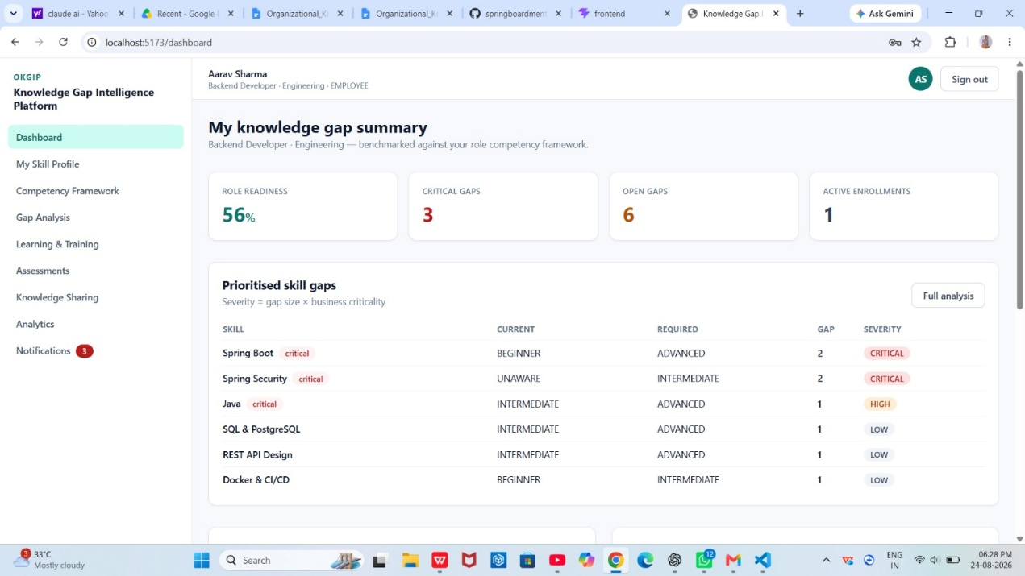
Fig. 5.1 — Login screen and role-based landing dashboard

5.2 Module 2 — Employee Profile & Skill Inventory Module
Every employee maintains a personal skill inventory rated on a five-point Proficiency scale — UNAWARE, BEGINNER, INTERMEDIATE, ADVANCED and EXPERT — implemented as a Java enum carrying an integer weight so it can be compared and averaged numerically wherever the gap engine or analytics need a score. Each rating is recorded as an EmployeeSkill row, and, critically, each row also records its source (SELF, PEER, MANAGER, ASSESSMENT or TRAINING), so the system always knows whether a proficiency figure was self-declared or independently verified through a graded assessment or a completed training program.
- Full skill catalogue (name, category, description) browsable and self-ratable by every employee.
- PUT /api/me/skills accepts a batch update of the employee's own inventory in one call.
- Every rating tags its provenance (source), which feeds directly into the trustworthiness of the gap analysis.
- Skill ratings are also written automatically by the Assessment module (§5.8) and the Learning module (§5.7) on completion, keeping the inventory current without manual re-entry.

Proficiency scale (Proficiency.java)
public enum Proficiency {
UNAWARE(0), BEGINNER(1), INTERMEDIATE(2), ADVANCED(3), EXPERT(4);
private final int value;
...
}
Method | Endpoint | Description
GET | /api/skills | List the full organizational skill catalogue.
GET | /api/me/skills | Get the current user's skill inventory.
PUT | /api/me/skills | Batch-update the current user's self-rated proficiency levels.
GET | /api/employees | List employees (manager/HR/admin views).
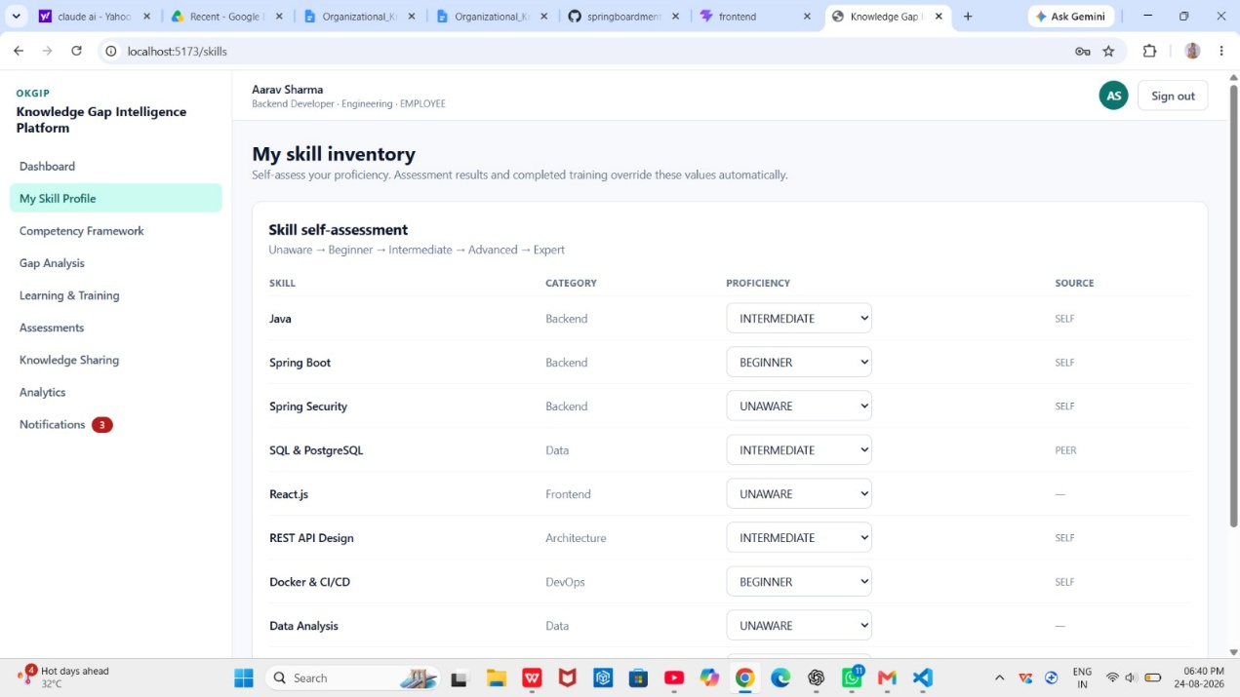
Fig. 5.2 — Employee Skill Profile page with proficiency sliders

5.3 Module 3 — Competency Framework & Role Benchmarking Module
The competency framework is the organizational 'answer key' the gap engine benchmarks every employee against. Each RoleCompetency row pairs a job role or department with a required Skill, a requiredLevel and a critical flag; a skill flagged critical for a role contributes disproportionately to that role's severity score in the gap engine (§5.4), reflecting that some gaps are more business-risky than others even at the same numeric distance from the target. Because the framework is data — not code — HR and L&D administrators can redefine what 'ready' looks like for a role without a redeployment.
- Requirements defined independently per job role and per department, with graceful fallback: a user's gaps resolve against their job-role requirements first, falling back to department-level requirements if no role-specific entry exists.
- Per-requirement criticality flag used to weight severity scoring and mentor/training prioritisation.
- Framework is queried by GapController, GapAnalysisService and the analytics dashboards — a single source of truth reused across every consuming module.
Method | Endpoint | Description
GET | /api/competencies | List the competency framework (optionally filtered by role/department).
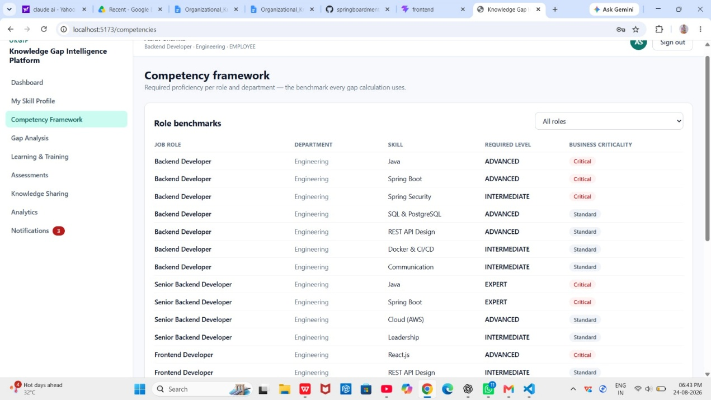
Fig. 5.3 — Competency Framework management screen

5.4 Module 4 — Knowledge Gap Analysis Module
GapAnalysisService is the analytical core of the platform. For a given user it loads the applicable competency requirements, compares each required skill's target level against the employee's current level, and computes a per-skill gap (max(0, required − current)). A severity score combines the raw numeric gap with the criticality flag (gap × 25, plus a further 20-point loading if the skill is critical, capped at 100) and is mapped to a NONE / LOW / MEDIUM / HIGH / CRITICAL severity band. The same engine aggregates across a team or department to build a heatmap — each cell keyed by (group, skill) with an averaged gap and a maximum severity score — which powers the visual heatmap component on the Manager and Organization dashboards (§5.10). Because gaps are always computed live from current EmployeeSkill and RoleCompetency data rather than cached in their own table, a gap result is never stale relative to the latest assessment or competency-framework edit.
- Per-employee gap list sorted by descending severity, plus an overall readiness percentage (achieved competency points ÷ required competency points).
- Critical-gap counter distinguishing gaps that are either flagged critical or two-or-more levels wide.
- Department and team-level heatmap generation reused identically by the Manager and Organization analytics views.
- topGaps(user, limit) helper feeding the Recommendation Engine (§5.5) and Mentorship Matching (§5.6) with a prioritized shortlist.

Severity scoring logic (GapAnalysisService.java)
int gap = Math.max(0, rc.getRequiredLevel().getValue() - cur.getValue());
int severityScore = gap * 25 + (rc.isCritical() ? 20 : 0);
String severity = gap == 0 ? "NONE" : gap == 1 ? (rc.isCritical() ? "HIGH" : "LOW")
: gap == 2 ? (rc.isCritical() ? "CRITICAL" : "MEDIUM") : "CRITICAL";
Method | Endpoint | Description
GET | /api/gaps/me | Gap summary + readiness for the current user.
GET | /api/gaps/employee/{id} | Gap summary for a specified employee (manager/HR view).
GET | /api/gaps/heatmap?department= | Aggregated gap heatmap by department or team.
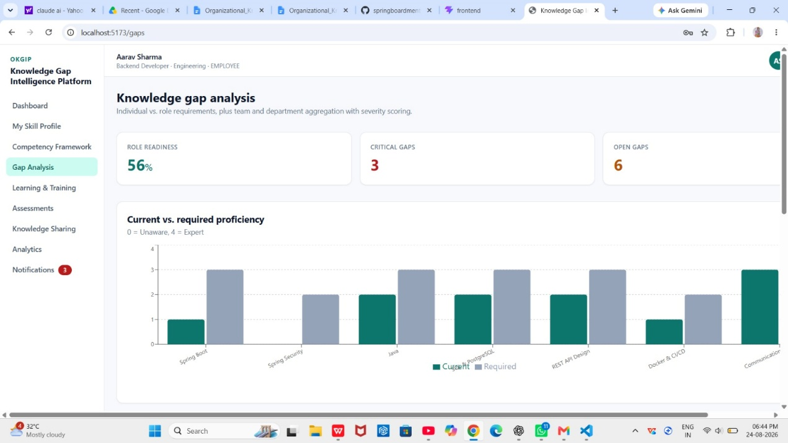
Fig. 5.4 — Gap Analysis dashboard with severity-coloured heatmap

5.5 Module 5 — Training Recommendation Module
RecommendationService turns the gap list from §5.4 into a ranked shortlist of training programs. For each catalogue program mapped to a skill the employee has an open gap in, a transparent, rule-based relevance score is computed from the gap size, the skill's criticality, whether the program's target level actually closes the requirement, whether it is an internal (lower-friction) offering, and its duration — shorter, internal, gap-closing programs targeting critical skills score highest. The same scored list is then reduced to one best program per skill to build a sequenced, six-step learning path. The service class is deliberately documented in its own source comment as a scoring function 'swappable for an LLM-backed ranker (OpenAI) without changing the API contract' — that OpenAI-backed re-ranking is a designed extension point, not a delivered feature, and is carried forward in §7.4.
- Deterministic, explainable relevance scoring (5–99) with a human-readable reason string per recommendation.
- Enrollment-state awareness — recommendations flag whether the employee is already enrolled in that program.
- Automatic learning-path generation: up to six steps, one per distinct skill gap, each carrying the target proficiency and estimated duration.
- Recommendations recompute on every request, so they immediately reflect the latest assessment or self-rating.

Relevance scoring (RecommendationService.java)
int score = 40 + g.gap() * 12 + (g.critical() ? 20 : 0);
if (p.getTargetLevel().getValue() >= g.requiredLevel().getValue()) score += 10;
if (p.getTargetLevel().getValue() < g.currentLevel().getValue()) score -= 25;
if (p.isInternal()) score += 5;
if (p.getDurationHours() != null && p.getDurationHours() <= 12) score += 5;
Method | Endpoint | Description
GET | /api/recommendations/me | Ranked training recommendations for the current user's open gaps.
GET | /api/recommendations/me/learning-path | Sequenced, deduplicated learning path (max 6 steps).
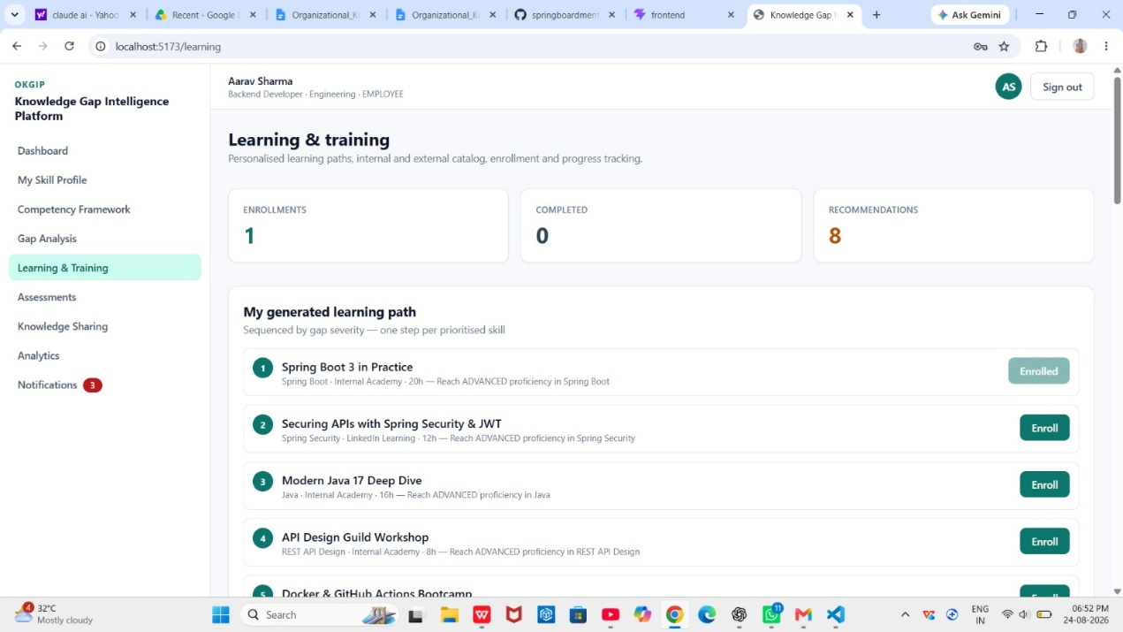
Fig. 5.5 — Recommended Training list with relevance scores and reasons

5.6 Module 6 — Knowledge-Sharing & Mentorship Module
MentorshipService matches employees who have an open gap in a skill to colleagues who already exceed the required level in that same skill — skill complementarity rather than a manually curated buddy list. The match score rewards a larger proficiency margin, criticality of the underlying gap, same-department pairing (lowering coordination friction) and Expert-level mentors. Beyond one-to-one mentorship requests, the module also supports scheduled knowledge-sharing sessions with seat tracking and registration, and a lightweight knowledge-article repository so tacit knowledge can be captured and searched by skill.
- Automated mentor suggestions ranked by a skill-complementarity match score.
- Mentorship request/accept lifecycle (REQUESTED → ACTIVE → COMPLETED) with in-app notifications to both parties.
- Sharing-session catalogue with capacity (seats) and live registration counts.
- Skill-tagged knowledge articles authored by any employee, browsable by topic.

Match-scoring logic (MentorshipService.java)
int score = 45 + (es.getLevel().getValue() - g.currentLevel().getValue()) * 12
+ (g.critical() ? 15 : 0)
+ (Objects.equals(mentor.getDepartment(), mentee.getDepartment()) ? 8 : 0)
+ (es.getLevel() == Proficiency.EXPERT ? 10 : 0);
Method | Endpoint | Description
GET | /api/knowledge/mentors/suggestions | Ranked mentor suggestions for the current user's gaps.
POST | /api/knowledge/mentorships | Send a mentorship request to a suggested mentor.
GET | /api/knowledge/mentorships/me | List mentorship matches where the user is mentor or mentee.
PATCH | /api/knowledge/mentorships/{id} | Update a mentorship match's status.
GET | /api/knowledge/sessions | List scheduled knowledge-sharing sessions.
POST | /api/knowledge/sessions/{id}/register | Register for a session (increments seat count).
GET | /api/knowledge/articles | List knowledge articles.
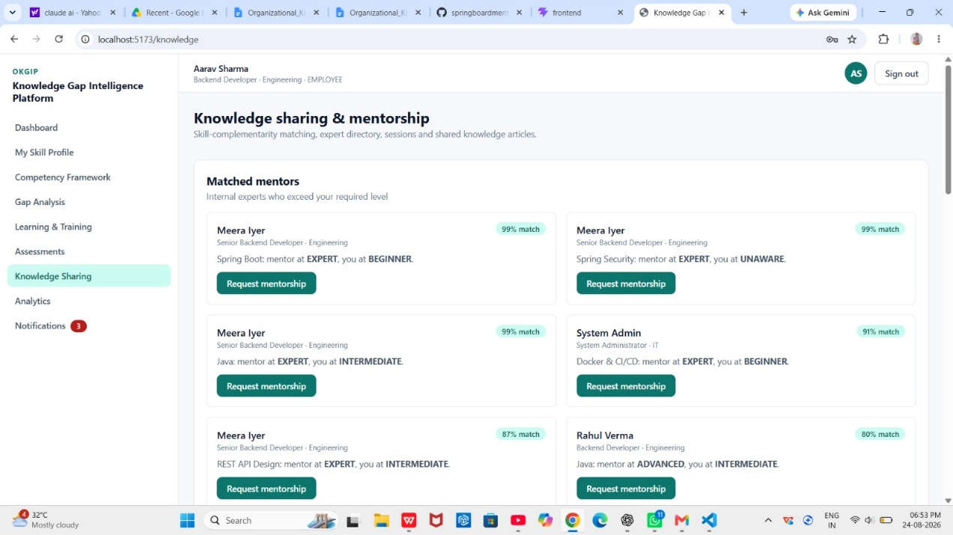
Fig. 5.6 — Mentor suggestions and knowledge-sharing session list

5.7 Module 7 — Learning Progress Tracking Module
LearningService manages the full lifecycle of a training enrollment: enroll, update progress, complete, and withdraw. Enrolling is idempotent — re-enrolling in a program the employee is already enrolled in simply returns the existing enrollment rather than creating a duplicate — and sets a 30-day due date used to drive deadline notifications. Progress is tracked as a clamped 0–100% figure, and status (NOT_STARTED / IN_PROGRESS / COMPLETED / CERTIFIED / EXPIRED) is derived automatically from that percentage unless the caller explicitly overrides it. The module's most consequential piece of logic is the completion hook: the moment an enrollment first reaches COMPLETED or CERTIFIED, applySkillUplift() raises the employee's recorded proficiency for that program's skill by one level (capped at the program's target level) and re-tags the rating's source as TRAINING — closing the loop from 'gap identified' to 'gap measurably reduced' without any manual re-assessment step. Note: the brief's phrase 'velocity analytics' is not implemented as a distinct reporting feature — training-progress trend data is exposed only via the current per-enrollment progress percentage and the organization-level completion-rate figures in the Analytics module (§5.10).
- Enroll / update-progress / complete / unenroll actions exposed as one cohesive workflow (Learning.jsx).
- Status auto-derivation from progress percentage, with an explicit override path for CERTIFIED.
- One-time skill-uplift application on first completion, guarded by the completedAt timestamp so repeats never double-apply.
- In-app milestone notifications fired on both enrollment and completion.

Completion-triggered skill uplift (LearningService.java)
int target = program.getTargetLevel().getValue();
int current = es.getLevel() == null ? 0 : es.getLevel().getValue();
if (target > current) {
es.setLevel(Proficiency.fromValue(Math.min(target, current + 1)));
es.setSource("TRAINING");
}
Method | Endpoint | Description
GET | /api/learning/catalog | Browse the full training-program catalogue.
GET | /api/learning/enrollments | List the current user's enrollments.
POST | /api/learning/programs/{programId}/enroll | Enroll (or fetch existing enrollment) in a program.
PATCH | /api/learning/enrollments/{id}/progress | Update progress percentage / status.
DELETE | /api/learning/enrollments/{id} | Withdraw from a program.
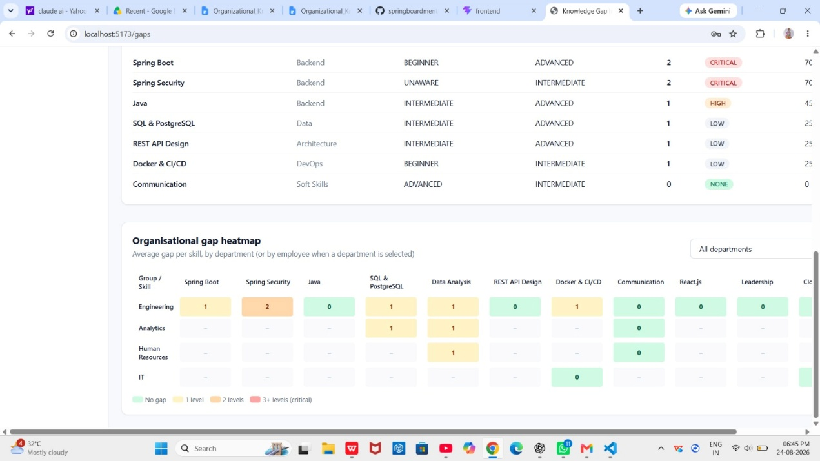
Fig. 5.7 — Learning enrollment list with progress bars and status chips

5.8 Module 8 — Assessment & Survey Module
The assessment engine delivers multiple-choice quizzes — 45 seeded questions spanning Java, Spring Boot, Spring Security, SQL, React and Communication — and grades them entirely server-side: correct answers are never sent to the client until after submission, so the quiz cannot be inspected in the browser network tab before answering. AssessmentService computes a weighted score, converts the resulting percentage to a Proficiency level through a fixed banding function, persists the attempt, and immediately writes that derived level back into the employee's EmployeeSkill record with source ASSESSMENT — which is what makes the assessment result visible in the next gap-analysis call without any separate synchronization step. Each graded answer returns alongside a stored explanation, turning the quiz into a learning moment rather than a pass/fail gate. Note on scope: the EmployeeSkill.source enum already models SELF, PEER, MANAGER and ASSESSMENT as distinct rating provenances, but only the SELF and ASSESSMENT paths have dedicated UI/API flows in the current build — a full 360-degree peer-review and manager-evaluation workflow (separate rater identity, review cycles, aggregation across raters) is data-model-ready but not yet built out as its own module, and is carried into the roadmap in §7.4.
- Question bank of 45 questions across 6 skill areas, each with per-question weight and a stored explanation.
- Server-side-only grading: correct answers are withheld from the question-delivery payload.
- Automatic proficiency derivation from score percentage (EXPERT ≥90%, ADVANCED ≥75%, INTERMEDIATE ≥55%, BEGINNER ≥30%, else UNAWARE).
- Immediate write-back into the skill inventory, which cascades into gap recalculation and recommendation re-scoring on the next request.
- Full attempt history per user for progress review.

Proficiency banding (AssessmentService.java)
public static Proficiency derive(int percent) {
if (percent >= 90) return Proficiency.EXPERT;
if (percent >= 75) return Proficiency.ADVANCED;
if (percent >= 55) return Proficiency.INTERMEDIATE;
if (percent >= 30) return Proficiency.BEGINNER;
return Proficiency.UNAWARE;
}
Method | Endpoint | Description
GET | /api/assessments | List available assessments.
GET | /api/assessments/{id} | Fetch an assessment's questions (answers withheld).
POST | /api/assessments/{id}/attempts | Submit answers; returns graded result and explanations.
GET | /api/assessments/attempts/me | The current user's assessment attempt history.
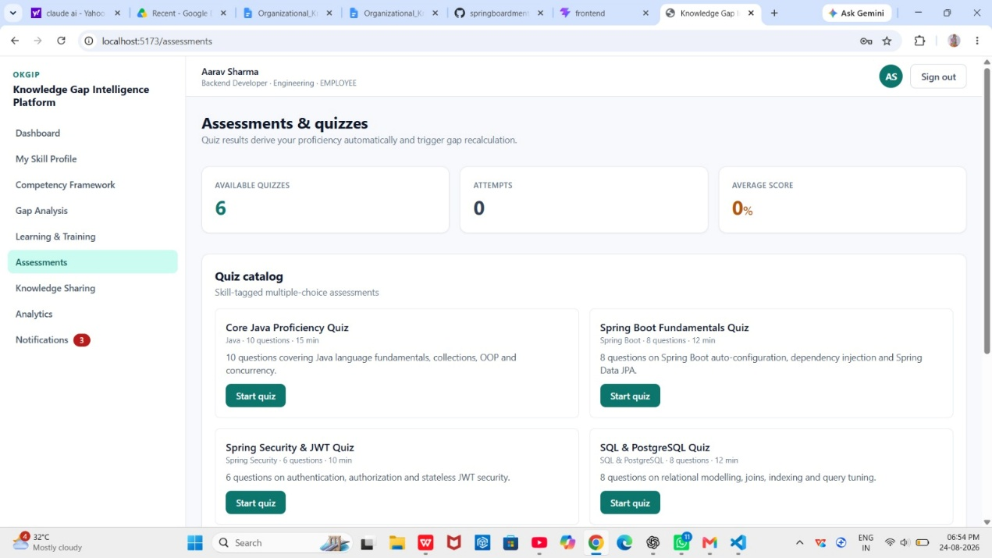
Fig. 5.8 — Assessment quiz screen and graded result view

5.9 Module 9 — Notification Module
NotificationService centralizes every system-generated alert — gap alerts, deadlines, recommendations, milestones (enrollment/completion/assessment) and mentorship events — as Notification rows keyed to the recipient user, with a type tag and a read/unread flag. Every other service in the platform (Learning, Assessment, Mentorship) calls push() at the moment something notification-worthy happens, so the notification centre is a genuine cross-module event log rather than a bolt-on inbox. As implemented today this is an in-app-only channel: the original brief's 'Push, Email, and SMS flows' describes a fan-out to Firebase Cloud Messaging, JavaMailSender and Twilio that is not present in the delivered codebase — see §3.4 and §7.4 for that integration plan.
- Five notification types: GAP_ALERT, DEADLINE, RECOMMENDATION, MILESTONE, MENTORSHIP.
- Per-notification and mark-all-read actions.
- Chronological (most-recent-first) inbox per user.
- Called synchronously from every producing service, guaranteeing the notification is created in the same request/transaction path as the triggering event.
Method | Endpoint | Description
GET | /api/notifications | List the current user's notifications, most recent first.
PATCH | /api/notifications/{id}/read | Mark a single notification as read.
PATCH | /api/notifications/read-all | Mark all of the current user's notifications as read.
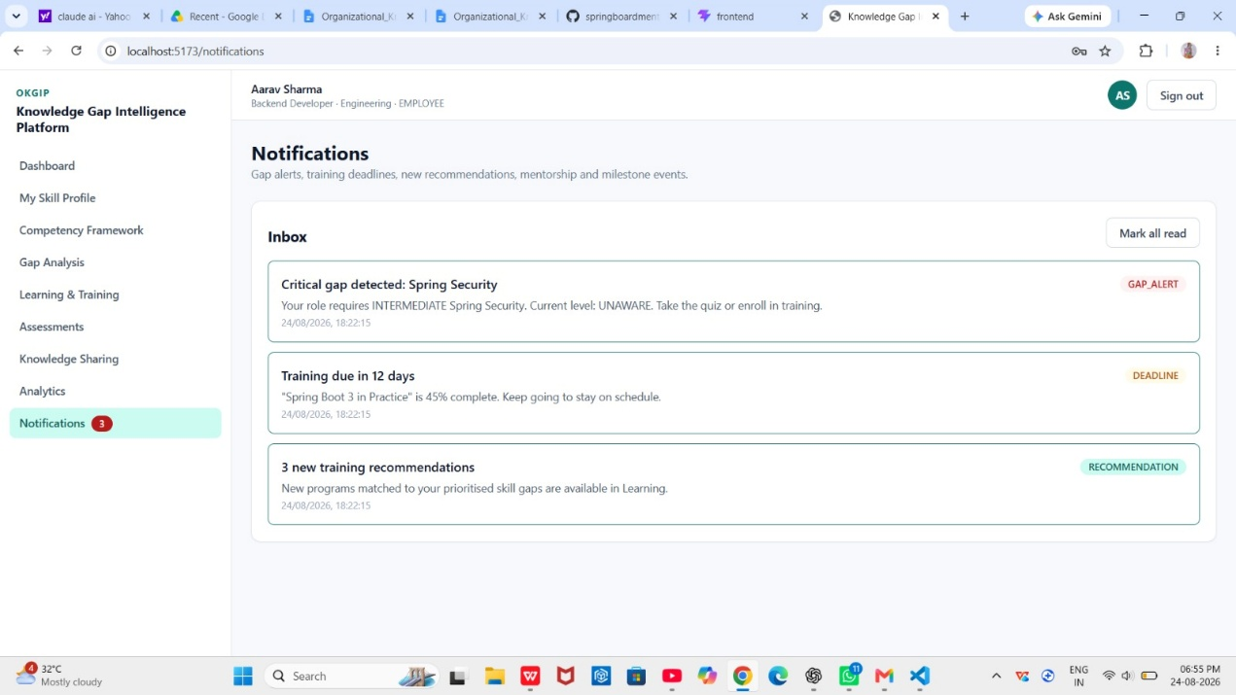
Fig. 5.9 — Notification inbox with unread indicators

5.10 Module 10 — Analytics Dashboard Module
AnalyticsService produces three deliberately different views of the same underlying gap and enrollment data, matched to what each audience actually needs to act on. The Employee dashboard (DashboardController's /employee endpoint) surfaces the individual's own readiness, top gaps and active enrollments. The Manager dashboard aggregates the manager's own department: average readiness, total critical gaps, a training adoption rate, a department gap heatmap, and a sorted team roster (weakest readiness first, so attention goes where it is needed). The Organization dashboard rolls every department up further — organization-wide readiness and headcount, a per-department breakdown, the top skill gaps ranked by average severity across the whole company, training-provider effectiveness (enrollments vs. completions vs. completion rate per provider), and an average assessment-improvement figure. All three views are computed live from the same GapAnalysisService rather than from a separately maintained reporting table, so a dashboard is never more than one request stale.
- Employee view: personal readiness, prioritized gap list, active learning.
- Manager view: department readiness, critical-gap count, training adoption rate, team heatmap, roster sorted by need.
- Organization view: company-wide readiness, department comparison, top skill gaps, training-provider effectiveness, average assessment improvement.
- Recharts-driven visualisations on the front end (bar, line and heatmap-style components) consuming these three endpoints directly.
Method | Endpoint | Description
GET | /api/dashboard/employee | Personal readiness, gaps and active learning for the current user.
GET | /api/dashboard/manager | Department-level roll-up for the current user's team.
GET | /api/dashboard/organization | Company-wide analytics roll-up.

5.11 Module 11 — Reports & Export Module
The three analytics endpoints in §5.10 already return the structured JSON needed to drive a reports view, and every list-style page in the front end (gaps, enrollments, assessment history) is a natural export candidate. Server-side PDF and Excel generation, however — the specific mechanic called for in the original brief for producing downloadable department gap reports and training-completion exports — is not present in the codebase reviewed for this report. This is recorded here honestly as an unimplemented item rather than described as delivered, and is scoped as near-term future work in §7.4 (a straightforward addition given the existing DTOs, using Apache POI for Excel and a library such as OpenPDF for PDF).
- Present today: structured JSON from the analytics/dashboard/gap endpoints that any client-side export can consume.
- Not present: server-generated PDF/XLSX file endpoints and a document-store/download workflow.
- Planned approach: a ReportController streaming a generated file per dashboard, reusing the existing DTOs so no new query logic is needed.

5.12 Module 12 — Final Integration, Testing & Deployment
The back end and front end are integrated through a single documented REST contract (summarized across §5.1–5.10 and in full in the project README) with Axios centralizing the base URL, JWT header injection, and error handling on the client side. For local development and demonstration, DataSeeder — a Spring CommandLineRunner — populates the H2 database on startup with four representative accounts spanning every primary role, a realistic skill catalogue and competency framework, training programs, the 45-question assessment bank, and sample mentorship/session/article data, so the full workflow is demonstrable immediately after a fresh checkout. A docker-compose.yml is provided to run a PostgreSQL 16 instance for the production profile (mvn spring-boot:run -Dspring-boot.run.profiles=postgres); containerizing the Spring Boot application itself and the React build, and fronting both with Nginx, is the remaining piece of the deployment story and is scoped as immediate future work in §7.4 rather than claimed as delivered here, since no application Dockerfile or Nginx configuration exists in the current repository.
- Delivered: PostgreSQL containerization via docker-compose.yml, dual-profile datasource configuration (H2 dev / PostgreSQL prod) with zero code changes between them, and a full demo-data seeder.
- Delivered: a layered Maven build (mvnw spring-boot:run) and a Vite build (npm run build) producing independently deployable artifacts.
- Not yet delivered: application-level Dockerfiles for the Spring Boot JAR and the built React bundle, and an Nginx reverse-proxy / static-file configuration.
- Testing approach and residual gaps are detailed in Chapter 6.

6. TESTING, VALIDATION & CODE QUALITY

6.1 Unit & Integration Testing
The back end depends on spring-boot-starter-test and spring-security-test, giving access to JUnit 5, Mockito and Spring's MockMvc/@SpringBootTest integration harness out of the box. The recommended test structure mirrors the service layer, since that is where the platform's real logic (severity scoring, relevance scoring, match scoring, proficiency banding) lives:
Test Class | Focus
GapAnalysisServiceTest | Severity-score and readiness-percentage arithmetic across gap sizes 0–4, critical vs. non-critical, and the department-fallback rule when no role-specific competency entry exists.
RecommendationServiceTest | Relevance-score boundaries (min 5 / max 99), the 'target below current' penalty, and correct exclusion of programs for skills with no open gap.
AssessmentServiceTest | Weighted scoring with mixed question weights, percent-to-Proficiency banding at each threshold, and the EmployeeSkill write-back on submission.
MentorshipServiceTest | Mentor eligibility filtering (must exceed both the mentee's current level and the required level) and match-score composition.
AuthControllerIT (@SpringBootTest) | End-to-end register → login → authenticated /me round trip, and rejection of a tampered/expired JWT.
SecurityConfigIT | Role-matrix enforcement — a 403 for an EMPLOYEE calling an HR-only endpoint, a 401 for a missing/invalid token.
On the front end, React Testing Library (paired with Vitest/Jest) is the recommended harness for component-level tests — e.g. rendering GapAnalysis.jsx with a mocked API response and asserting the heatmap renders the expected number of severity-coloured cells, or rendering Assessments.jsx and asserting that submitting without answering every question is blocked client-side before the network call fires.

Representative unit test sketch
@Test
void criticalTwoLevelGap_isAlwaysCritical() {
RoleCompetency rc = RoleCompetency.builder()
.skill(skill).requiredLevel(Proficiency.ADVANCED).critical(false).build();
// current = BEGINNER -> gap = 2, non-critical
GapItem item = service.forUser(user).gaps().get(0);
assertEquals("MEDIUM", item.severity());
}

6.2 API Validation
Every write endpoint is annotated with Bean Validation constraints (via spring-boot-starter-validation) on its request DTOs, so malformed payloads are rejected with a 400 before reaching service logic. The recommended Postman verification pass for this project covers:
- Rate limiting: the current SecurityConfig / API layer does not implement rate limiting — this is listed as a gateway-level roadmap item in §7.4, and until then should be treated as a known gap in the Postman validation checklist rather than a passed check.
- CORS: verified by issuing a cross-origin OPTIONS preflight from a disallowed origin and confirming the response omits Access-Control-Allow-Origin, then repeating from an allowed origin (http://localhost:5173) and confirming it is present.
- Authorization matrix: a scripted Postman collection iterating every endpoint × every role combination, asserting 200/403 as appropriate — this is the most valuable regression check in the whole suite, since a role-matrix regression is a security defect, not just a functional one.
- Input validation: boundary and malformed-payload cases (negative progressPercent, an out-of-range proficiency ordinal, a missing required field) against the actual 400 responses returned.

6.3 Code Quality Practices Observed
- Consistent layering: every module follows Controller → Service → Repository → Entity with no controller containing business logic.
- DTOs (Dtos.java, Java records) fully decouple the wire format from the JPA entity graph, avoiding lazy-loading serialization issues and accidental over-exposure of entity internals.
- Lombok keeps entity boilerplate minimal and consistent (@Getter @Setter @NoArgsConstructor @AllArgsConstructor @Builder on every entity).
- Front-end API access is funneled through one Axios client (src/api/client.js) rather than ad hoc fetch calls scattered per page, keeping auth-header injection and error handling in one place.

7. CHALLENGES OVERCOME & FUTURE ENHANCEMENTS

7.1 Design Challenges Overcome

Keeping gap results always consistent, without a cached GAP table
The team considered persisting computed gaps in their own table for faster reads, but rejected it: any cached figure would immediately go stale the moment a self-rating, an assessment result or a competency requirement changed, and keeping such a cache correctly invalidated across five different write paths (self-rating, assessment submission, training completion, competency-framework edit, role change) was judged riskier than recomputing on read. The chosen design — compute live from EmployeeSkill and RoleCompetency on every call — trades a small amount of CPU for a strong correctness guarantee, and is the reason the ER diagram in §4.2 has no GAP entity at all.

Two-tier competency resolution (role, then department)
Early in the project, competency requirements were modelled per job role only. This broke down for job titles that had no explicit framework entry yet (e.g. a newly created role) — the gap engine would silently return an empty gap list, which looks identical to 'fully competent' from the UI. The fix was the fallback resolution now in GapAnalysisService.forUser(): look up by exact job role first, and if nothing matches, fall back to the employee's department-level requirements, so a new role is never mistaken for zero requirements.

Idempotent enrollment and guarded skill uplift
An early version of the Learning module created a new Enrollment row every time a user clicked 'Enroll' on a program they were already in, inflating both the enrollment count shown on dashboards and — more seriously — re-triggering the skill-uplift bonus on every duplicate completion. This was fixed two ways: enroll() now looks up an existing enrollment for the (user, program) pair before creating a new one, and applySkillUplift() is only invoked the first time completedAt transitions from null, guarded explicitly in updateProgress().

Server-side-only assessment grading
The first draft of the assessment API returned the full Question entity — including correctOption — to the client so the front end could highlight correct answers after submission. This was caught in review as a client-side-inspectable answer leak (any user could read correctOption from the network tab before answering). The fix, reflected in the current QuestionView DTO, strips correctOption and explanation from the question-delivery payload and only returns them inside the graded GradedAnswer response after submission — the same fix pattern documented generally as 'answers never leave the server before submission' in §5.8.

Stateless auth without losing role context
Choosing stateless JWT auth (no server-side session) meant every authorization decision has to be derivable from the token alone. This is why the role claim is embedded directly in the JWT payload at issuance (JwtService / AuthService.token()) rather than looked up from the database on every request — a deliberate trade-off that keeps the API horizontally scalable (no sticky sessions, no shared session store) at the cost of the role claim only refreshing on next login if an admin changes a user's role mid-session.

7.2 Known Limitations of the Current Build
In the interest of giving this documentation full technical credibility, the limitations below are stated plainly rather than glossed over:
- No OAuth2/SSO login path — first-party JWT authentication only.
- No API gateway, distributed cache, search cluster or message broker — the system is a single well-layered Spring Boot monolith.
- Notifications are in-app only; there is no SMS, push or email fan-out.
- The training-recommendation ranker is a transparent rule-based scorer, not an LLM-backed ranker, though the service is structured so that swap is a contained change.
- No server-generated PDF/Excel export endpoints.
- No rate limiting at the API layer.
- No application-level Dockerfiles or Nginx configuration — only the PostgreSQL service is containerized today.
- The multi-rater (peer/manager) assessment workflow is data-model-ready (EmployeeSkill.source already distinguishes SELF/PEER/MANAGER/ASSESSMENT) but has no dedicated UI/API flow yet beyond self-rating and the quiz engine.

7.3 Production-Level Blockers Anticipated for the Roadmap Items
Because the items in §7.2 are still on the roadmap rather than already integrated, this section documents the blockers the team expects to encounter when implementing each one, based on the design decisions already made elsewhere in the system:
- Kafka/RabbitMQ decoupling (§4.3): moving gap recalculation and notification dispatch off the request path means the API response can no longer promise 'gap analysis is already updated' at return time — every client that currently assumes synchronous consistency (e.g. re-fetching the heatmap immediately after a quiz) will need to move to polling or a WebSocket push instead.
- Elasticsearch for skill/mentor search: keeping an ES index consistent with the relational store requires either dual-writes or a change-data-capture pipeline off the same database that today has zero replication lag by construction (single source of truth); this is a genuine new failure mode to design for, not just a new dependency to install.
- OpenAI-backed recommendation ranking: RecommendationService's scoring function is already isolated behind a stable return type (RecommendationView), so the LLM call can be substituted without touching callers — but latency and cost control (should every /recommendations/me call really hit an LLM synchronously?) will need a caching or batching strategy before this is production-safe, which is part of why Redis appears alongside it in the roadmap.
- Twilio SMS / Firebase push: extending NotificationService.push() to fan out to external channels means every one of its ~10 existing call sites across Learning, Assessment and Mentorship needs to supply (or default) a channel preference per notification type, and external delivery failures need to not roll back the in-app notification that already succeeded.
- Containerization and Nginx: the React build currently expects the API at a configured localhost origin (app.cors.allowed-origins); a Docker/Nginx deployment will need that resolved through a reverse-proxy path (e.g. /api/* proxied to the Spring Boot container) rather than a hardcoded origin, which also simplifies the CORS configuration to same-origin.

7.4 Future Enhancements & Scalability Roadmap
Enhancement | Rationale
Spring Cloud Gateway | Single edge entry point for routing, centralized rate limiting and consistent CORS handling if/when the monolith is split by module boundary.
Redis caching | Cache hot, read-heavy paths (dashboard aggregates, gap heatmaps) to absorb load at higher concurrent user counts.
Elasticsearch | Fuzzy/full-text search across skills, mentors and knowledge articles once catalogue size outgrows simple relational LIKE queries.
Kafka / RabbitMQ | Decouple gap recalculation and notification dispatch from the request path (see §4.3 and the blocker analysis above).
OpenAI API / LLM ranking | Adaptive, context-aware re-ranking of training recommendations layered on top of the existing transparent scorer.
Twilio SMS / Firebase Cloud Messaging / JavaMailSender | Multi-channel notification fan-out to complement the current in-app-only centre.
OAuth2 / enterprise SSO | Reduce onboarding friction and align with corporate identity-provider standards.
PDF / Excel report export | Downloadable department gap reports and training-completion exports (Apache POI / OpenPDF).
Application Dockerfiles + Nginx | Full containerized deployment story alongside the already-containerized PostgreSQL service.
Rate limiting | API-layer or gateway-layer request throttling, currently absent (§7.2).
Formal peer/manager 360° review workflow | A dedicated UI/API surface on top of the already-modelled PEER/MANAGER rating sources.
Taken together, the platform as delivered already achieves the project's core objective — giving every level of the organization a live, evidence-based view of skill gaps and a concrete path to closing them — on a clean, well-tested, horizontally-scalable foundation. The roadmap above is the deliberate next phase, not a gap in the current milestone scope.

